COMP308 – Jim’s Tournament Bracket

External Document

Group 10 – Jason Huang (300818592), Jeff Li (), Jon Lee (), Franco Chong ()

Jim’s Corporation  First Draft March 31, 2017

Contents

Part 1: Project Concept & Site Security 2

Overview 2

Roles of the Team 2

Future Functionality 2

Design of the Site 3

Rough UI Wireframe Sketches 3

Color Designs 4

Design of the Logo 4

Test Cases 5

Register Test Case 5

Login Test Case 6

Screen Capture Section 7

# Part 1: Project Concept & Site Security

## Overview

Our team will be working on creating a Tournament Bracket site that allows users to manage their own tournaments online. We are focusing on a single elimination tournament bracket web application. The web application we are creating will contain the following basic core functionality.

Core Functionality include:

* Register and Login System
* Users can manage their own tournament by
  + Adding players
  + Removing players
  + Switch the players around in the bracket
  + Mark the tournament as Live and Finished (the players are locked in position)
* Generate a graphical representation of the bracket

Technologies being used are:

* Node.js
* Express
* Passport
* M-Lab
* Heroku
* And more

## Roles of the Team

**Project Manager** – Jason H

**Engineer** – Jeff L

**Designer** – Franco C

**Quality** **Assurance**/**Tester** – Jon L

## Future Functionality

There are many things that we want to include in our web application and here are some future things to add:

* Host a sign-up page for public tournaments
* Advance Match Winners based on recorded score (instead of typing who advances manually)*
* Search bar to find other tournaments
* Add other tournaments types such as double elimination, swiss etc. (un-decided which ones)

# Design of the Site

## Rough UI Wireframe Sketches

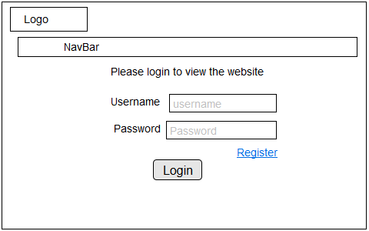

**Figure 1: Wireframe for the login page**

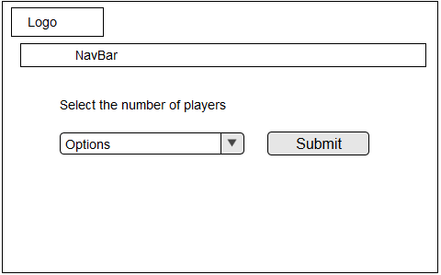

**Figure 2: Wireframe for the player select page**

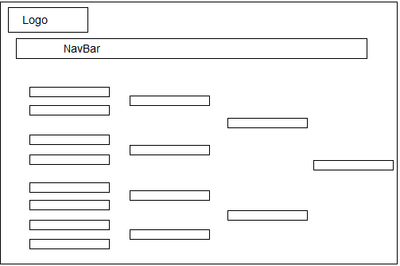

**Figure 3: Sample of the tournament bracket page**

## Color Designs

**Background:** Dark grey

**Text:** either Yellow, Red, orange or a color that is soothing to the eyes**.**

**Reason for the choices:** The goal of the colors on the website is to make it as comfortable as possible for the user’s eyes.

## Design of the Logo



JT represents the name of the web application Jim’s Tournament and the curly brackets represent the tournament brackets. This is a the first draft of the logo, their maybe changes in the future.

# Test Cases

## Register Test Case

|  |  |
| --- | --- |
| **Test Case ID:** Test_01 | **Test Designed by:** Jonathan Lee |
| **Test Priority (Low/Medium/High):** High | **Test Designed date:** March 30, 2017 |
| **Module Name:** register screen | **Test Executed by:** Jonathan Lee |
| **Test Title:** Verify register with valid username and password | **Test Execution date:** March 30, 2017 |
| **Description:** Test the register page |  |

**Pre-conditions:** User has valid email, username and password

**Dependencies**: User has previously registered

|  |  |  |  |  |  |
| --- | --- | --- | --- | --- | --- |
| Step | Test Steps | Test Data | Expected Results | Actual Result | Status (Pass/Fail) |
| 1 | Navigate to login page |  | User should be able to view login page | User was able to view login page | Pass |
| 2 | Navigate to register page |  | User should be able to navigate to register page | User was able to view register page | Pass |
| 3 | Provide valid email, username, password | Email: tomisawesome@example.com  Username: JPL  Password: 1234 | User should be able to type in the required fields | User was able to type input into the required fields | Pass |
| 4 | Click on register button |  | User should be able to click button | User was able to click button and see result | Pass |
| 5 | Auto navigates to homepage |  | User should be able to view homepage | User was able to view homepage | Pass |

**Post-conditions**: User is registered with database and successfully login to account. The account details are logged in database.

Related Figures: 1.1 and 1.2

## Login Test Case

|  |  |
| --- | --- |
| **Test Case ID:** Test_01 | **Test Designed by:** Jonathan Lee |
| **Test Priority (Low/Medium/High):** High | **Test Designed date:** March 30, 2017 |
| **Module Name:** login screen | **Test Executed by:** Jonathan Lee |
| **Test Title:** Verify login with valid username and password | **Test Execution date:** March 30, 2017 |
| **Description:** Test the login page |  |

Pre-conditions: User has valid username and password

Dependencies:

|  |  |  |  |  |  |
| --- | --- | --- | --- | --- | --- |
| Step | Test Steps | Test Data | Expected Results | Actual Result | Status (Pass/Fail) |
| 1 | Navigate to login page |  | User should be able to view login page | User was able to view login page | Pass |
| 2 | Provide valid email, username, password | Username: JPL  Password: 1234 | User should be able to type in the required fields | User was able to type input into the required fields | Pass |
| 3 | Click on login button |  | User should be able to click button | User was able to click button and see result | Pass |
| 4 | Auto navigates to homepage |  | User should be able to view homepage | User was able to view homepage | Pass |

**Post-conditions**: User is validated with database and successfully login to account. The account details are logged in database.

Related Figures: 1.3

# Screen Capture Section

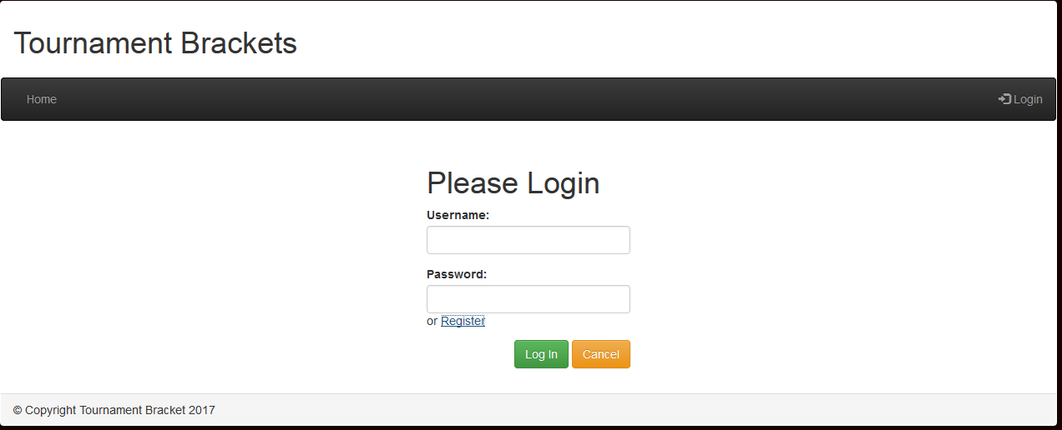

**Figure 1.1 Register Test Login Page**

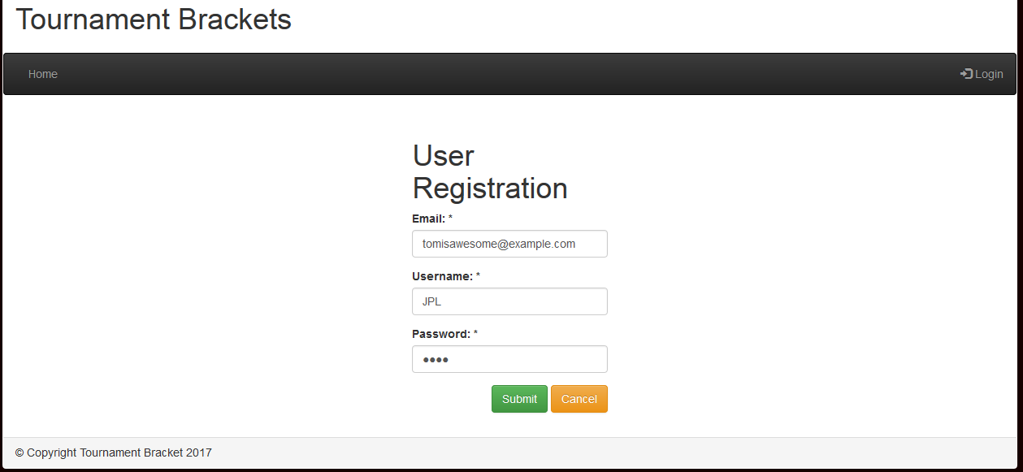

**Figure 1.2 Register Test, Registration Page, User Input**

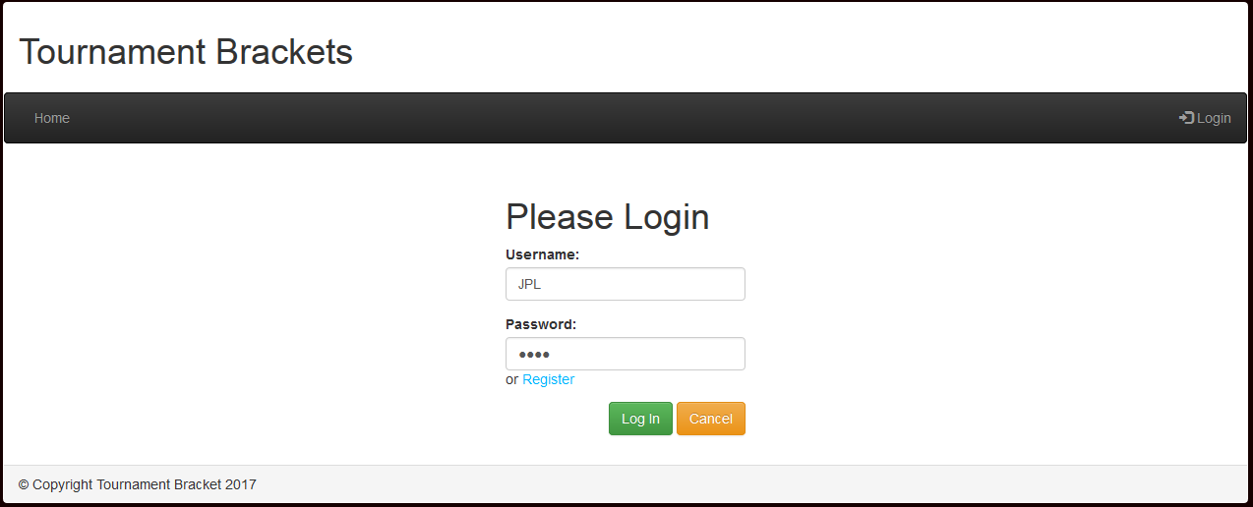

**Figure 1.3 Login Test Page, User Login Input**